What is Correlated with the US Traffic Accident?

2019 US Accident Visualization Report

He Qing 19450141

Shi Yi 19451512

Liu Zhaoxing 19456182

Mai Kailun 19456506

Hong Kong Baptist University

What is correlated with the US traffic accident?

2019 US Accident Visualization Report

# **Background**

The traffic accident is one of the events with a high death toll and strong contingency in modern society. The global epidemic of road traffic deaths and disabilities increasingly recognized as a significant public health problem. The first step to understanding global road safety and developing effective road safety interventions is to know the facts. What is the occurrence of traffic accidents correlated to?

The purpose of this visualization project is to explore the external factors that affected traffic accidents in the United States in 2019, and to draw some conclusions from them, to help American drivers reduce traffic accidents in the future. We use the countrywide traffic accident dataset, which covers 49 states of the United States in the year 2019. This data uses two APIs that provide streaming traffic event data. These APIs broadcast traffic events captured by various entities, such as U.S. and state transportation departments, law enforcement agencies, traffic cameras, and traffic sensors in the road network.

# **Method**

In our research, we used Python and Tableau to analyze and visualize the data. According to the dataset, we decided to mainly visualize the basic overview of the traffic accidents and how traffic POI factors and weather factors (such as temperature and humidity) are related to the severity of the accident in the U.S.

To show the overview of the accidents, there are three aspects, which are the severity, the seasonal distribution and geographic distribution of the traffic accidents. We used a combination of pie chart and box plot to show the different severity, a histogram to visualize the seasonal distribution of varying severity of traffic accident. Furthermore, we drew a histogram with a line to represent the number of traffic accidents and the severity mean in different cities, respectively. To better show a sense of geographical position, we also drew a map to visualize the number and severity in various cities and conduct further analysis.

As for the influence of different factors (traffic POI and weather), we used Tableau to draw a histogram and a dashboard to visualize the frequency of traffic accidents in various weather conditions. Through Python, we attracted a boxplot to see the relationship between pressure and temperature with the severity of accidents.

And we also analyze how serious traffic accidents are with or without the traffic POI in daytime or night, and the different traffic POI. Therefore, we used Tableau to draw two histograms to show the number of accidents in the above situations.

# **Result**

## Overview

First of all, we would like to show some graphs for the general overview of 953,630 traffic accidents in the U.S. in 2019.

According to the dataset, the traffic accidents are classified into four severity from 1 to 4, where 1 indicates the least impact on traffic (i.e., short delay and no one injured as a result of the accident) and 4 indicates a significant impact on traffic (i.e., long delay and probably people dead in the accident). 手机屏幕截图

Fig1. Severity

The pie chart, shown as Fig1, shows that almost all accidents caused 2-3 level severity of impact on traffic. Accidents with 2 severity takes up nearly 3/4 (687,573), ones with 3 severity 1/4 (237,790). Only less than 3% of cases (28,065) led to very severe impact on traffic, a few cases with light severity.

Fig2. Number of Accidents with Severity = 4 of Cities by State

Although the number of severity-4 accidents is small, it is still meaningful to focus on significant accidents. As we can see in the box plot, the numbers of severity-4 traffic accidents in 2019 in most cities are within 100. However, the figures in several cities in Florida (FL) is far more than 100, and Mai Ami is the city with most severity-4 accidents (779) in the country.手机截图图社交软件的信息

Fig3. Seasonal Distribution for Severity

As shown in the Fig3, in the winter there are most frequent traffic accidents, especially for level 2 severity (220,501). However, more serious accidents occurred more often in the first season, with 7,604 for level 4 and 65,158 for level 3. Given the difference between seasons, we wonder if weather factor is a correlative to the severity of traffic accident.

Fig4. Geographic Distribution

In Fig4, the bar chart shows the number of accidents of each state, and the line presents the severity mean of all accidents taking place there. As we can see, California (CA) has a significant lager number (231,307) of accidents than other states, and the following 6 states also have huge figures between 40 and 80 thousand, but luckily their severity are not high. What is notable is that three states with fewest accidents (below 200), Wyoming, South Dakota, and North Dakota have high severity means (over 3.0).

Fig5. Map of Severity

As shown is the map, the color changes represent the severity mean, and the number label is the number of accidents of each state. We can see the states with highest mean of severity yet fewest accidents are in the northern central part of US. Maybe geographic situation there is not friendly for developing transportation, so the traffic is small and capability of recovering traffic is weak.

Where traffic is more developed, the number of car accidents will increase, but at the same time the impact of car accidents will be resolved more quickly. Furtherly, setting traffic signs is one of most important measure to improve traffic situation. Based on the observation and the dataset, we suppose the severity of a car accident in a place with traffic instructions will be lower than in a place without traffic instructions.

## Weather factors on traffic accidents

Weather condition contains the weather information about the day when accident happened, including temperature(F), wind chill(F), humidity (%), pressure(in), visibility(mi), wind direction, wind speed(mph), precipitation(in), general weather. We suppose that weather conditions can have some correlation to severity of accidents. Also, the visibility could be important to how serious an accident is, and the precipitation could be too.

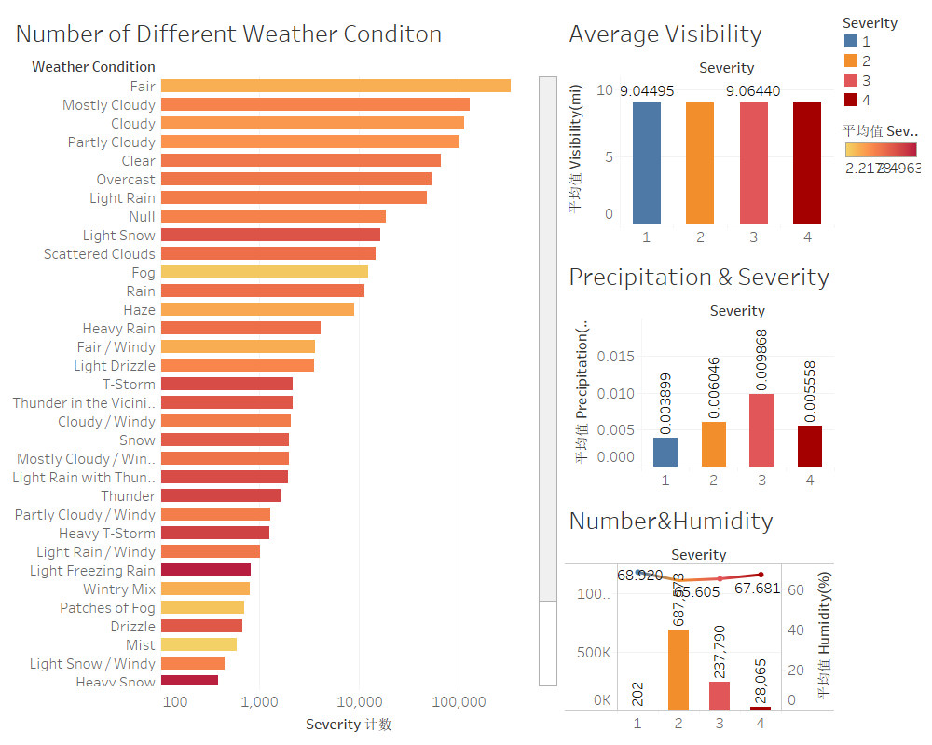

Fig7. Dashboard of Weather Condition

As can be seen in the dashboard in Fig7, accidents mostly happened in fair weather and the total number of it is more than 300 thousand. For other weather condition, they are much fewer. However, the difference between average severity of accidents in different weather is quite obvious. Accidents happened in critical weather like snow, thunder, or heavy thunderstorm, showers in the vicinity had higher average severity than accidents happened in normal weather like fair day or cloudy day. The average visibility has almost no difference in different accident severity, neither does the average humidity. However, for average precipitation, it has obvious difference, accident with third level of severity has higher average precipitation and the second and forth severity have almost the same average precipitation, probably because road gets wet after rain and the overcast weather make people distract from driving.

Fig8. Pressure and Severity Fig9. Temperature and Severity

The relationship of pressure and temperature with severity of accidents are shown in Fig8 and Fig9. Accidents usually happen in usual pressure at 30 inches hg, but there are a few accidents happening in unusual pressure which are extremely low. As for temperature, accidents usually happened in the most commonly temperature which is from 50 F to 100F and it is quite usual.

## Traffic POI factors on traffic accidents

POI, which means a point of interest, is a specific point location that someone may find useful or interesting. Most consumers use the term when referring to hotels, campsites, fuel stations or any other categories used in modern automotive navigation systems. In this dataset, we use POI to represent different traffic signs.

Fig10. Traffic POI in Day and Night

In Fig10 we could see that traffic accidents were less happened with POI signs than without it, and accidents with POI signs during the day had the lowest severity. At the same time, we can also see that road sections without POI signs have a higher average severity of traffic accidents at night, reaching to 2.3884. Also, there are usually more accidents during the day than at night. Traffic authorities should put up more traffic signs on highways to help drivers predict the road sections and reduce the occurrence of traffic accidents.

Fig11. Different Kinds of Traffic POI that Influenced the Accident Severity

In Fig 11 we could also see that there will be more accidents without traffic signs. In 2019, the number of accidents without POI signs in the United States was as high as 696,988, and the average severity of the accidents was reaching 2.352. Among the Traffic accidents with POI signs, the nearby Traffic signs on the Top 3 number of accidents were Traffic signal, Junction and Crossing. The most serious accident occurred near junction, with an average severity of 2.428. Drivers must pay attention to the junction when driving on the highway. Meanwhile, we could also see that the presence of a turning loop sign had no effect on the occurrence of a traffic accident.

# **Conclusion and Limitation**

We have explored the relationship between weather and accidents, traffic signs and accidents, time and accidents. In conclusion, accidents will not usually be benign with severity at 1. Once a car accident happens, it has more than 99% chance to be dangerous, so it is significant to avoid any chance to have a car accident. Another finding is that accidents happen more frequently in the daytime probably as a result of people going out in the daytime. POI can have an obvious correlation with accident severity, as the average severity is lower than those on the road without POI. Guess that because drivers may have noticed the traffic signs and concentrated on the road, so they can act quicker when having situations on the road.

Weather conditions do have some correlation with the severity of accidents, accidents happened in critical weather may be more serious than fair weather. The wind direction, average visibility and humidity have less correlation with the number and severity of accidents. Precipitation has a strong correlation with the severity of accidents, but it is not the same as how we supposed.

In a word, we must avoid any car accidents. To reach that goal, governments are supposed to set up more necessary traffic signals or signs on roads. Also, driving in daytime and night deserve the same concentration. Driving in critical weather conditions needs more concentration. In conclusion, drivers should pay more attention to nearby traffic signs and bad weather conditions to avoid traffic accidents.